

West Wales Regional Athletics Council

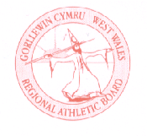
Minutes – West Wales Regional Athletics Council Annual General Meeting
Thursday 15th August 2024
Llanelli Leisure Centre / Microsoft Teams Meeting

Present: Rob Campion (RC) Chairman
Nathan Jones (NJ) Secretary
Les Cuthbert (LC) Treasurer
Andrew Jenkins (AJ) Afan Nedd Tawe Schools Athletic Association
Steve Hames (SH) Welfare Officer
Lisa Campion (LC) Track & Field Committee Representative
Gareth Harries (GH) Officials Secretary
Jennifer Boyce (JB) Pembrokeshire Harriers
Nigel Jones (NJ) Endurance Officials Committee Representative
Neil Thomas (NT) Carmarthen Harriers
Helen Williams (HW) Llanelli AAC
Rachel Evans (RE) Llanelli AAC

Chairman RC welcomed those present to the region’s 28th Annual General Meeting.

- Apologies Kevin Tobin, Owain Schiavone

- Minutes of previous AGM (18 August 2023)
The minutes of the AGM 2023 were checked for accuracy and accepted as a true record.
- Matters arising from previous meeting
None
- Chairman’s Report
RC - 2024 has been another successful year for West Wales. Firstly, I’d like to thank all officers, officials and team mangers that have helped and supported events throughout the year. Once again, our Junior Development League has shone through, we continue to be the only region that offers a full programme of events through all our meetings. This is down to the hard work of those clubs hosting, our officials supporting each event and the support of committee members and parents to ensure the smooth running.
We continue to bring back West Wales Championship events! This weekend will see the first of those with the 10k Championships at St Clears and then the Half Marathon Championships to take place at Dale on Sunday 29th September 2024.
Whilst we are blessed with many officials within the region there is always a need for more to ease pressure on those we do have. We held a successful track judging course before our first Junior League meeting at Swansea which brought in new faces. The plan will be to hold similar courses throughout the next year.
Funding within the region is our toughest challenge, with Welsh Athletics losing funding this is obviously having a ripple effect on the regions. In particular, our budget to purchase regional medals has been cut by half and the onus is now on regions to source their own. Therefore, our challenge is to continue the support and development within the region but on a tighter budget or possibly look outwards in terms of sponsorship to help.
In summary I’m extremely proud to be leading a region that supports each other with everything we do. On track we continue to excel in everything we offer our athletes, in all disciplines off track we have such a wealth of knowledge and expertise that it continues to drive forward with our committee’s support.
Looking forward to another successful year going forward.

- Treasurer’s Report
LC - The current (commodity) bank account on the AGM date is £7,364 (AGM 23: £7,279). This will however reduce to £3,327 after still to be received/paid invoices are considered (see attached A-1 for further breakdown).
The savings account on the AGM date stands at £13,077 (AGM 23: £10,528). This has been bolstered during the past year by the transfer of £2,400 from the Louise Arthur League and interest payments.
- W2RAC main income during the year has once again been stripe receipts from competition entry fees. As such the top five receipts are:
- Competition entry fees: £13,309
- Regional/Development grants £3,000
- Sales of athletic clothing: £1,745
- YDL UAG Club contribution: £400
- YDL UAG Bus Receipts: £176
2. W2RAC main expenses during the year has been Competition venue hire. There is one outstanding invoice to be received/paid. This will increase venue total shown below by estimated £600. The top five expenses are:
- Competition Venue hire: £3,831
- 2023 WWJL Dividend: £3,201
- Competition First Aid: £1,891
- Purchase of athletic clothing: £1,806
- Purchase of Assets (Equipment): £1,509
3. W2RAC Fixed Assets based on S/L Dpn to Aug 2024 are:
- Starter System: £1,938
- Pole Vault Pole: £989
- Gazebo: £567
- Wind Gauge: £511
4. W2RAC Clothing stock based on sale price:
- Athletic Vest/Crop Tops (66 units): £1,599
- Officials/ Volunteers Clothing: £0
- Increase of the following expenses over previous year:
- First Aid: £800
- Venue: £668
- Meeting Refreshments: £485
- Photo finish (per hire): £125 (too many scenarios in the past year where equipment has been missing after being hired out)
- Estimated Dividend to three 2024 WWJL Host Clubs:
- Carmarthen: £1,080
- Neath: £1,080
- Swansea: £1,080

- Discuss contribution increase for YDL UAG Clubs contribution due to likely rise in entry fee next year and possible bus hire to venues – AGREED: increase to £150.00 per club to support with costs
- Discuss feasibility of one First Aid provider attending all West Wales sponsored events at a reduced cost – AGREED: Providers depend on area of region, remain with several organisations for now
- Any future purchases by non-committee members £500 and above needs written request containing:
- Total Cost including VAT and P&P.
- Date required.
- Why the item is needed including benefits of having it for W2RAC Athletes/Officials/Volunteers.
- What would happen if not then purchased.
- Where would item be stored.
- Who would be responsible for it.
- If damaged, who pays for repairs.
Submission could be on an email or using a standard proforma – AGREED: Criteria above to be followed.

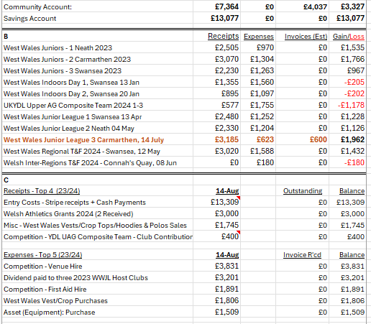
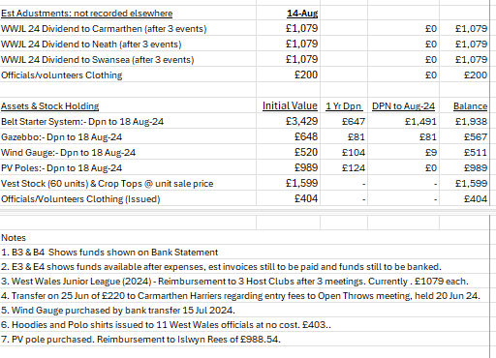

- Officials’ Secretary Report
GH – Thank you to all the officials and volunteers in the region for their contributions during the year. Clubs are reminded to encourage new volunteers to join as there are a variety of roles across all disciplines. Junior Leagues and Regional Championships is a good starting point.
At the current time, there are 113 registered officials within West Wales and about 80% active. Welsh Athletics will be sending their availability form for the indoor season in a few weeks time on a google form.

- Election of Officers
The following were elected for the year 2024/2025:
1) Chairman: Rob Campion
2) Hon Secretary: Nathan Jones
3) Hon Treasurer: Les Cuthbert
4) Officials’ Secretary: Gareth Harries
5) Welfare Officer: Steve Hames

- Delegates to Welsh Athletics Committees
1) General Council: Rob Campion/Steve Hames
2) Officials Committee (Endurance): Nigel Jones
3) Track & Field Committee: Lisa Campion
4) Road Running & Cross-Country Committee: Kevin Tobin
5) Trail, Mountain & Fell Running Committee: Owain Schiavone, supported by Dic Evans

- Notice of Motion

None

- Date of Next Meeting
West Wales Regional Athletics Council: Friday 18th October at 6:30pm at TBC

